## **EXPERIMENT NO. 5**

**Aim:** Develop Content (text, emoticons, image, audio, video) based social media analytics model for business. (e.g. Content Based Analysis: Topic, Issue, Trend, sentiment/opinion analysis, audio, video, image analytics)

**Theory:**

**Content-based Social Media Analytics:**

Developing a content-based social media analytics model for businesses is a crucial step in understanding their audience and improving their social media presence. Content-based social media analytics is a process of analyzing the content shared on social media platforms by a business or its customers. It helps businesses to understand their audience, identify emerging trends, and improve their social media strategy. Content-based analysis can be used for text, emoticons, image, audio, and video analytics.

**Topic Analysis**: It is the process of identifying the topics and themes in social media content. This can help businesses to understand the interests of their audience and create content that resonates with them.

**Issue Analysis**: It is the process of identifying the issues and concerns of the audience. This can help businesses to address the concerns of their audience and improve their social media presence.

**Trend Analysis**: It is the process of identifying the emerging trends in social media content. This can help businesses to stay up-to-date with the latest trends and adapt their social media strategy accordingly.

**Sentiment Analysis**: It is the process of identifying the sentiment or opinion expressed in social media content. This can help businesses to understand the sentiment of their audience towards their brand, products, or services.

**Audio, Video, and Image Analytics**: It is the process of analyzing audio, video, and image content shared on social media platforms. This can help businesses to identify the type of content that resonates with their audience and create similar content to improve engagement.

**Brand24 Tool:**

**Brand24** is a social media monitoring and analytics tool that helps businesses track online mentions, sentiment, and trends. It collects data from platforms like Twitter, Instagram, Facebook, YouTube, and blogs, providing insights into brand reputation, audience opinions, and content performance.

**Key Features:**

* **Mentions Tracking**: Monitor brand, product, or competitor mentions in real-time.
* **Sentiment Analysis**: Analyze whether mentions are positive, negative, or neutral.
* **Hashtag and Trend Analysis**: Identify popular hashtags and emerging topics.
* **Image Recognition**: Detect logos and visuals associated with your brand.
* **Influencer Identification**: Find key influencers driving conversations about your brand.

**Use Case:**

Brand24 is useful for businesses to:

* Monitor their online presence.
* Respond to customer feedback quickly.
* Analyze the success of marketing campaigns.
* Stay ahead of competitors by tracking trends and sentiment.

**Step 1:** Go to [Brand24](https://www.googleadservices.com/pagead/aclk?sa=L&ai=DChcSEwiaxvHllu2KAxWg2EwCHWtrKNAYABADGgJ0bQ&ae=2&aspm=1&co=1&ase=5&gclid=CjwKCAiAp4O8BhAkEiwAqv2UqGckiFVSD_fWNhengbOWh9uXDBOnIpHBF2qNpuRKmFNc6fYQr3PqHRoC4PwQAvD_BwE&ohost=www.google.com&cid=CAESVeD2OUSiyUgYKvm0KNcvKCQV8t46XGuNj-9pqqBhQFEfx4dWi7i6Gry3WLsp3kyx8wNQpXJQ08pOdaUhM2ZPaBXlFvcJP05ceRhQVH6es6-66ZnV5J8&sig=AOD64_1nrh-l3Yp5RXjSkmn7m0sGzvCksA&q&adurl&ved=2ahUKEwiY5uzllu2KAxUqka8BHeAtCvEQ0Qx6BAgMEAE) and sign in using your google account. After sign in, the following page will be displayed. Enter any social media platform and create a project.

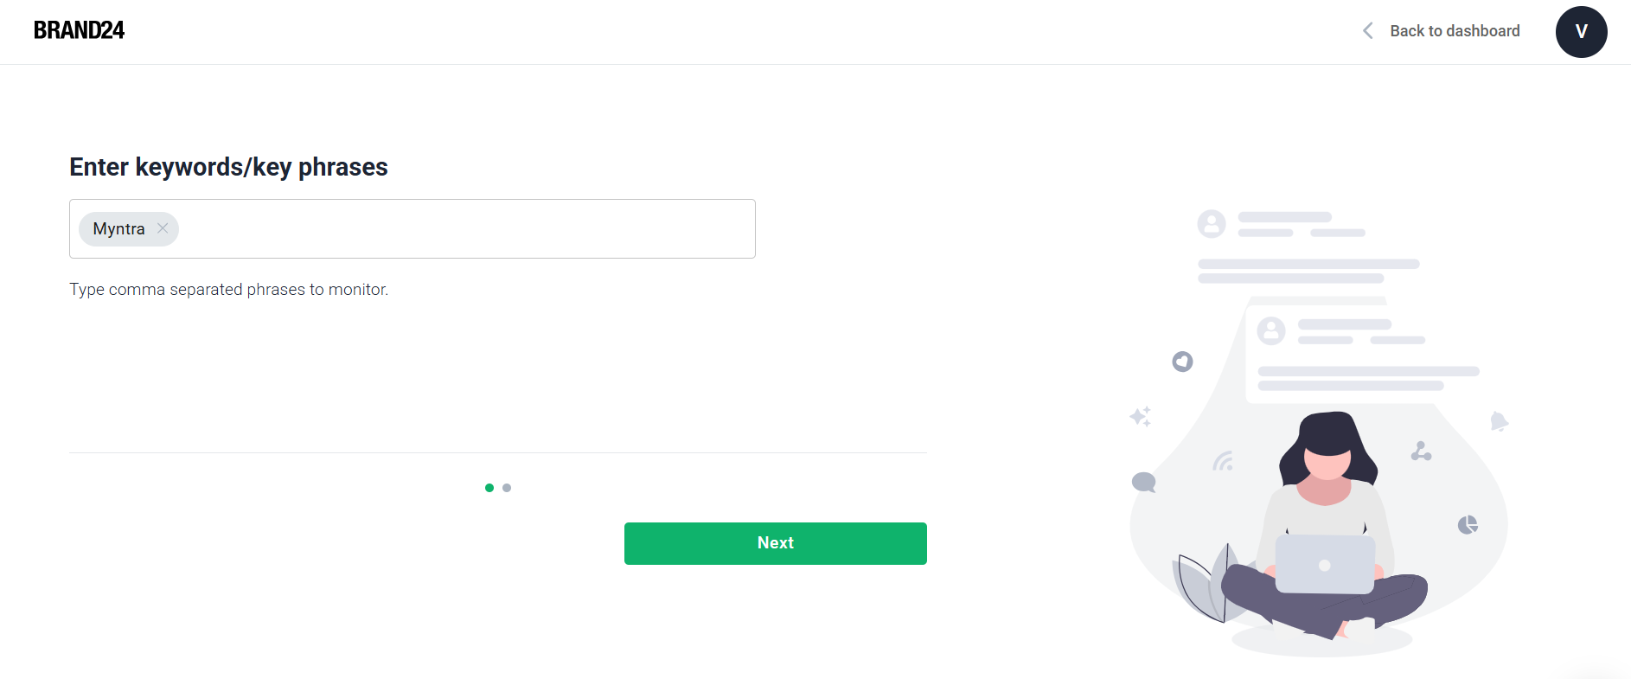

**Step 2:** After creating the project the following dashboard will be displayed.

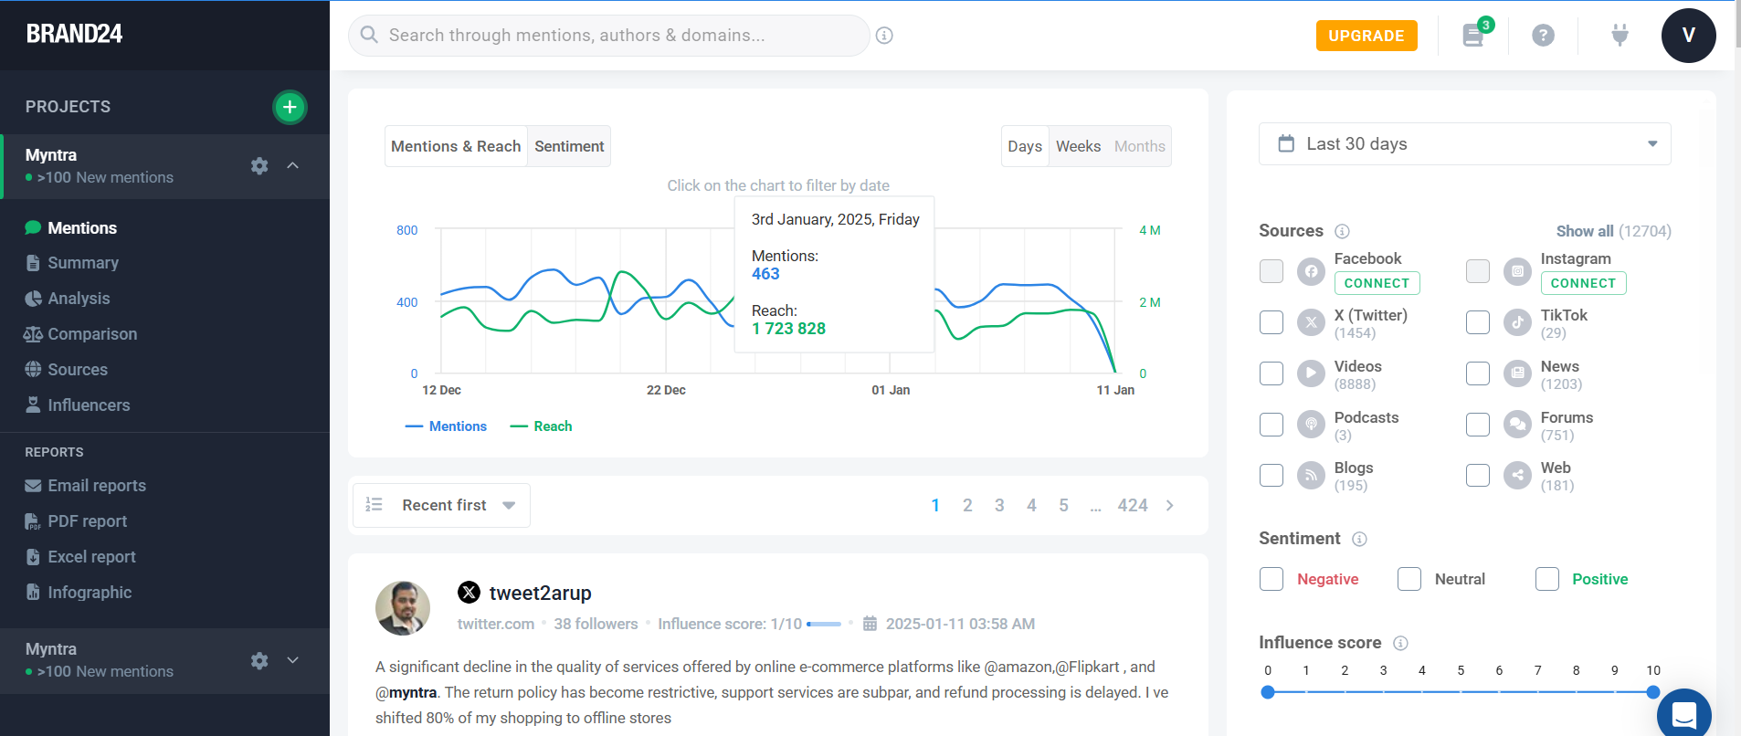

**Step 3:** Select summary.

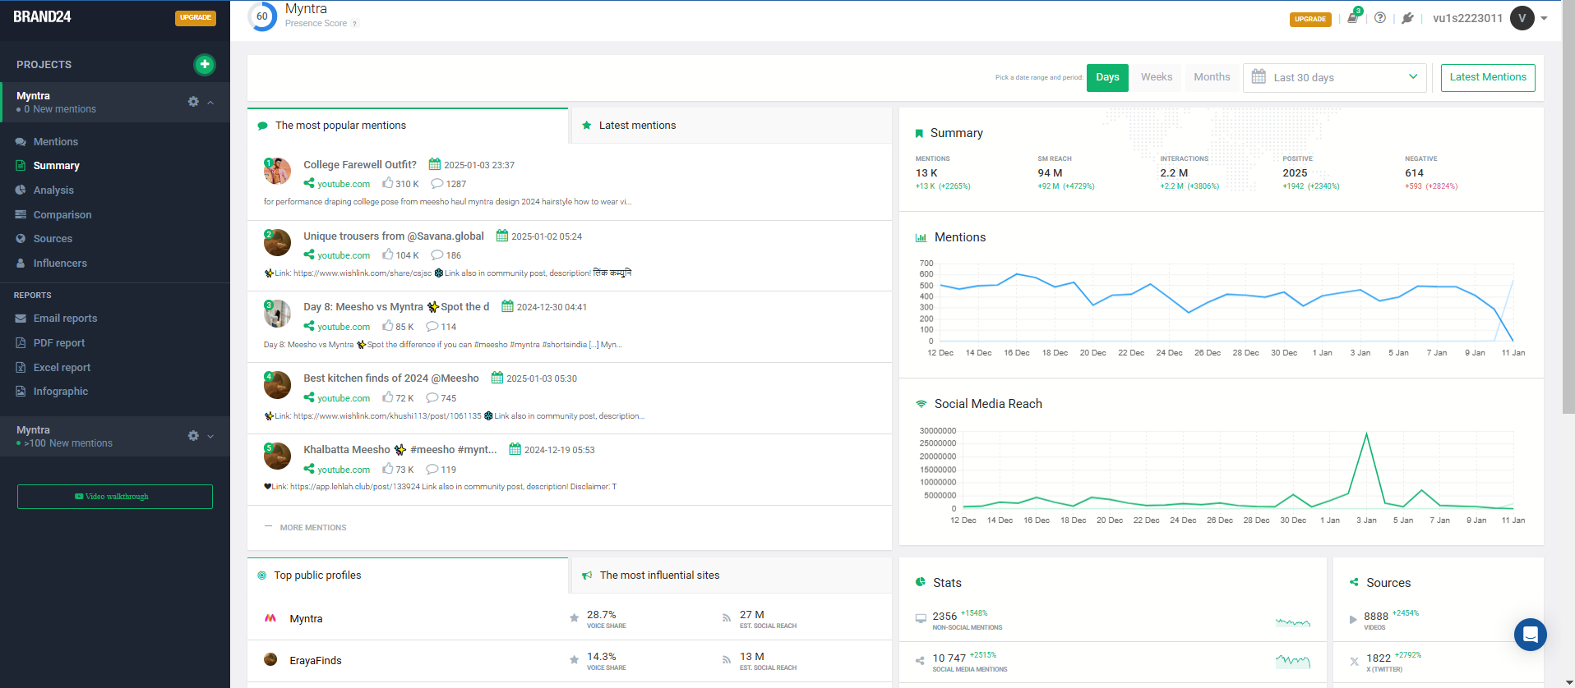

**Step 4:** Select Analysis.

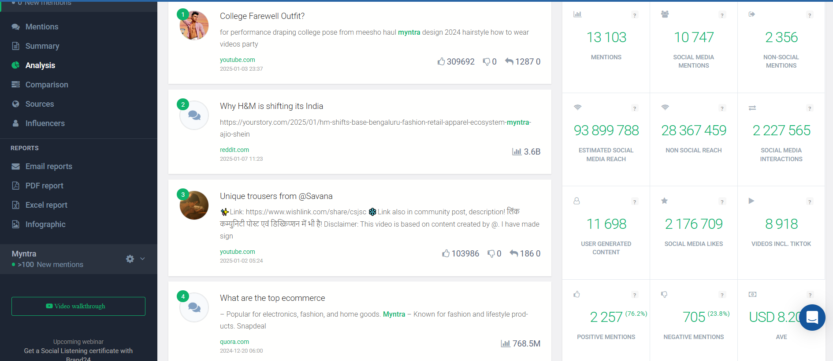

**Step 5:** Select various sources.

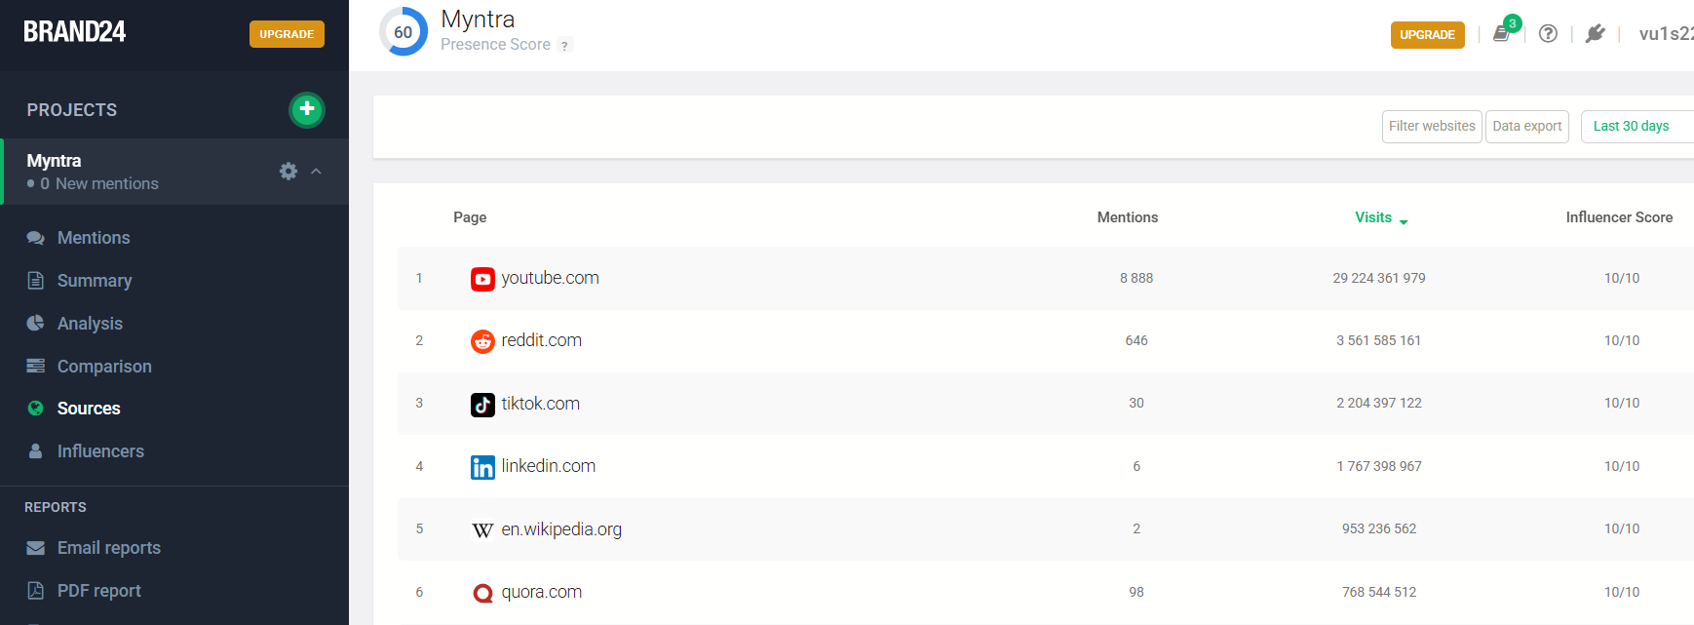

**Step 6:** Add filter as YouTube.

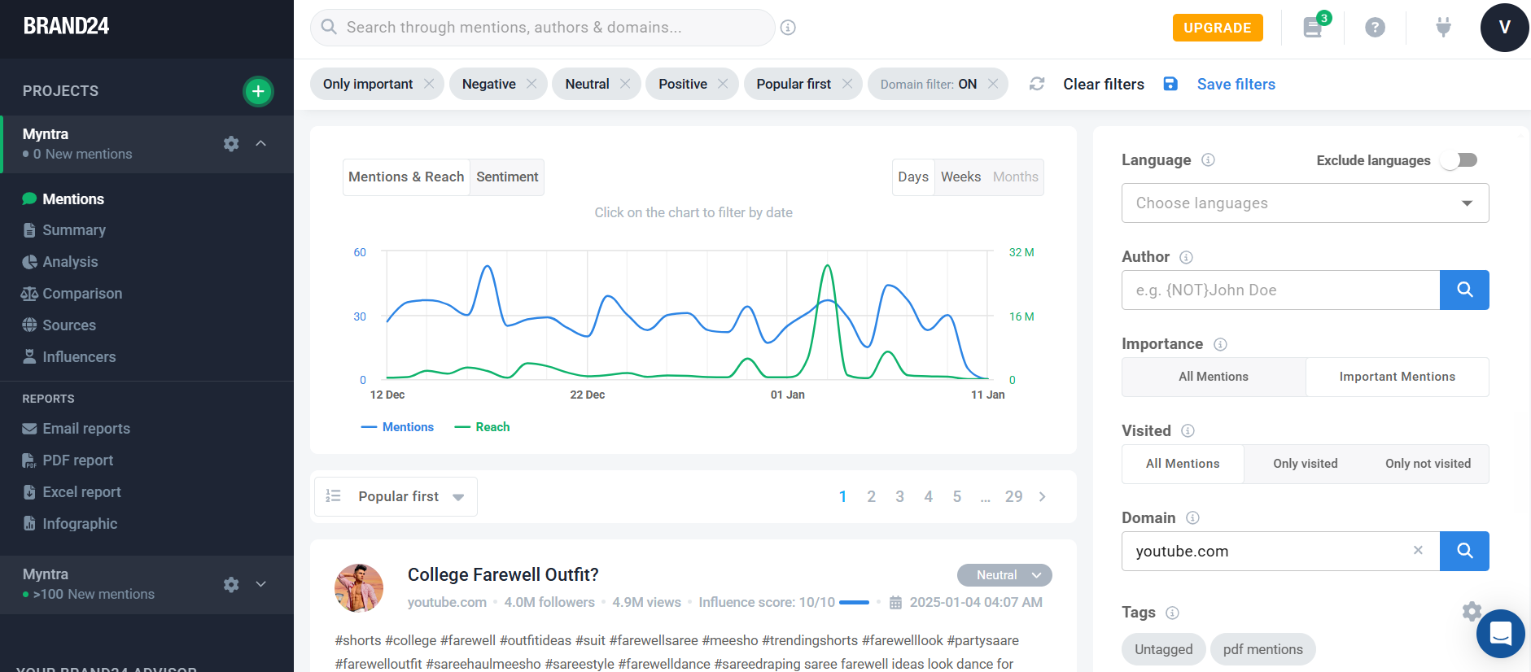

**Step 7:** Select Influencers.

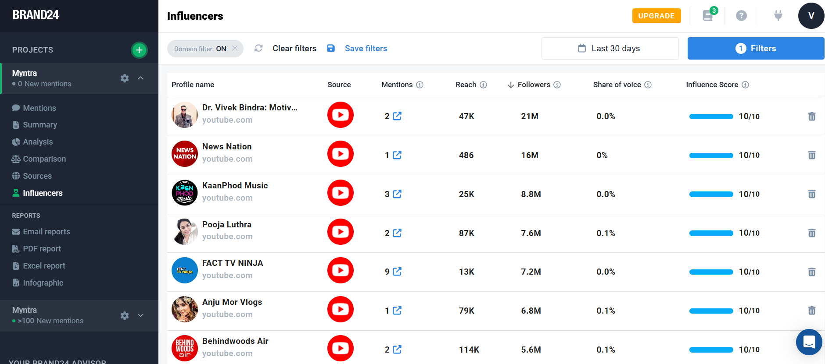

**Step 8:** Select Infographic.

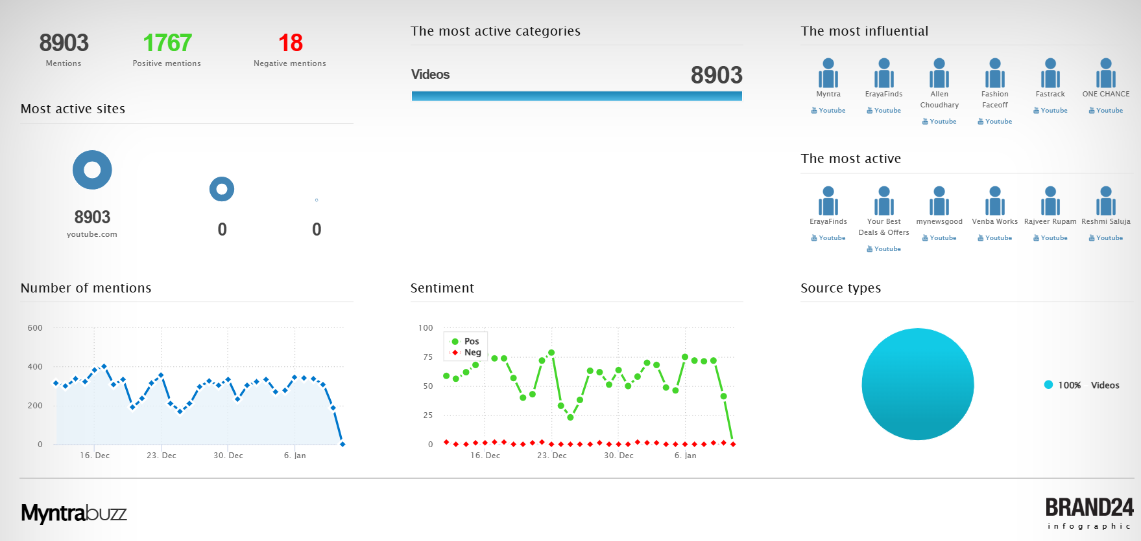

**Step 9:** Create a new project of any brand. Do the same process give above. Select Comparison and then select the brand you want to compare with.

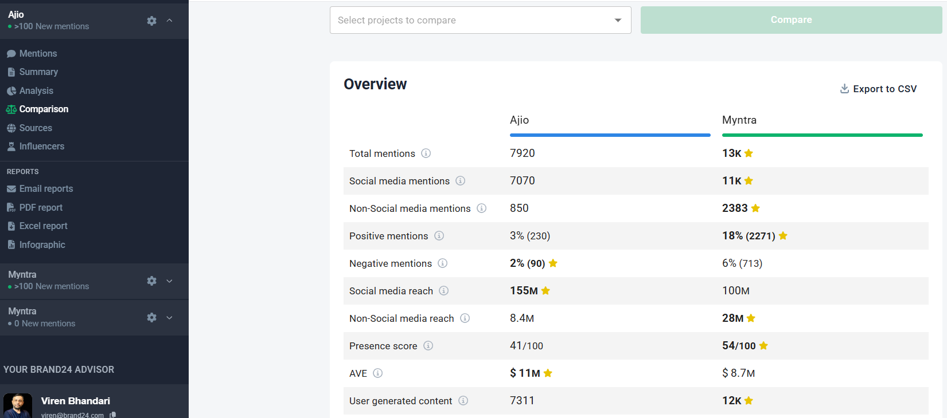

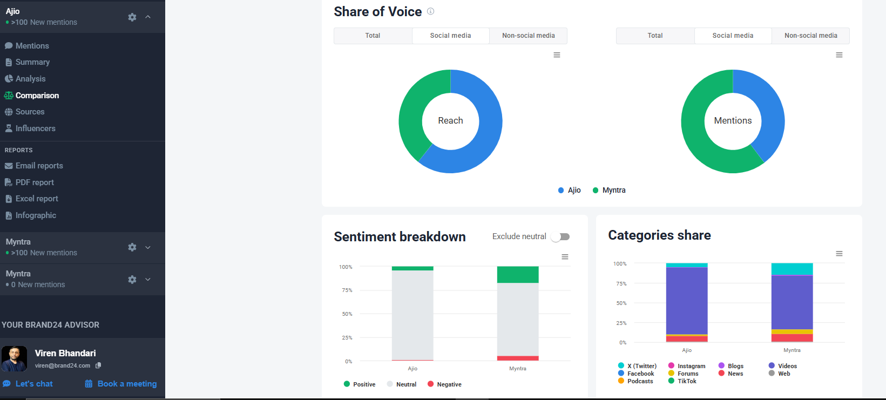

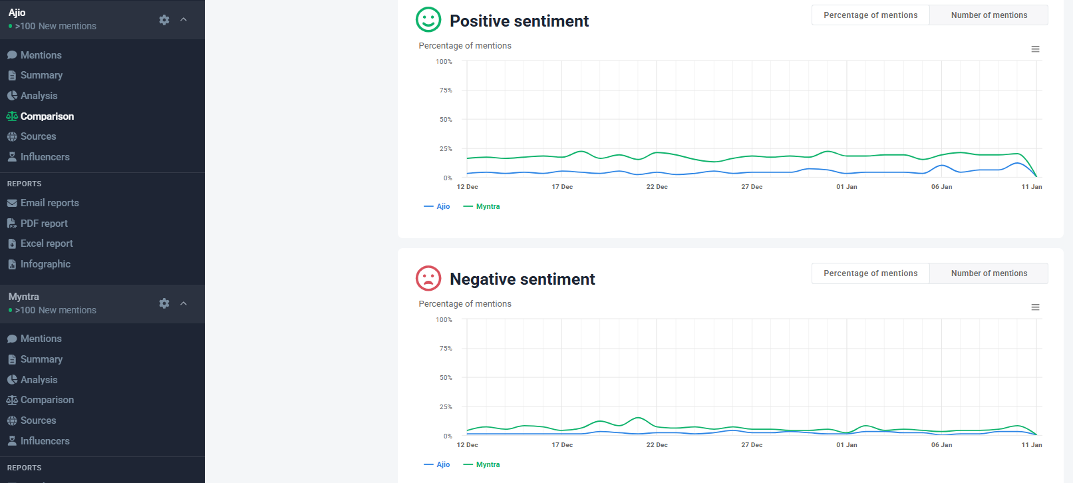

**Conclusion:**

Thus, Brand24 was used successfully to develop content based social media analytics models for business.